DAY1: Swagger API Test Case generation:
Class Assignment:
Swagger link: https://petstore3.swagger.io/api/v3/openapi.json
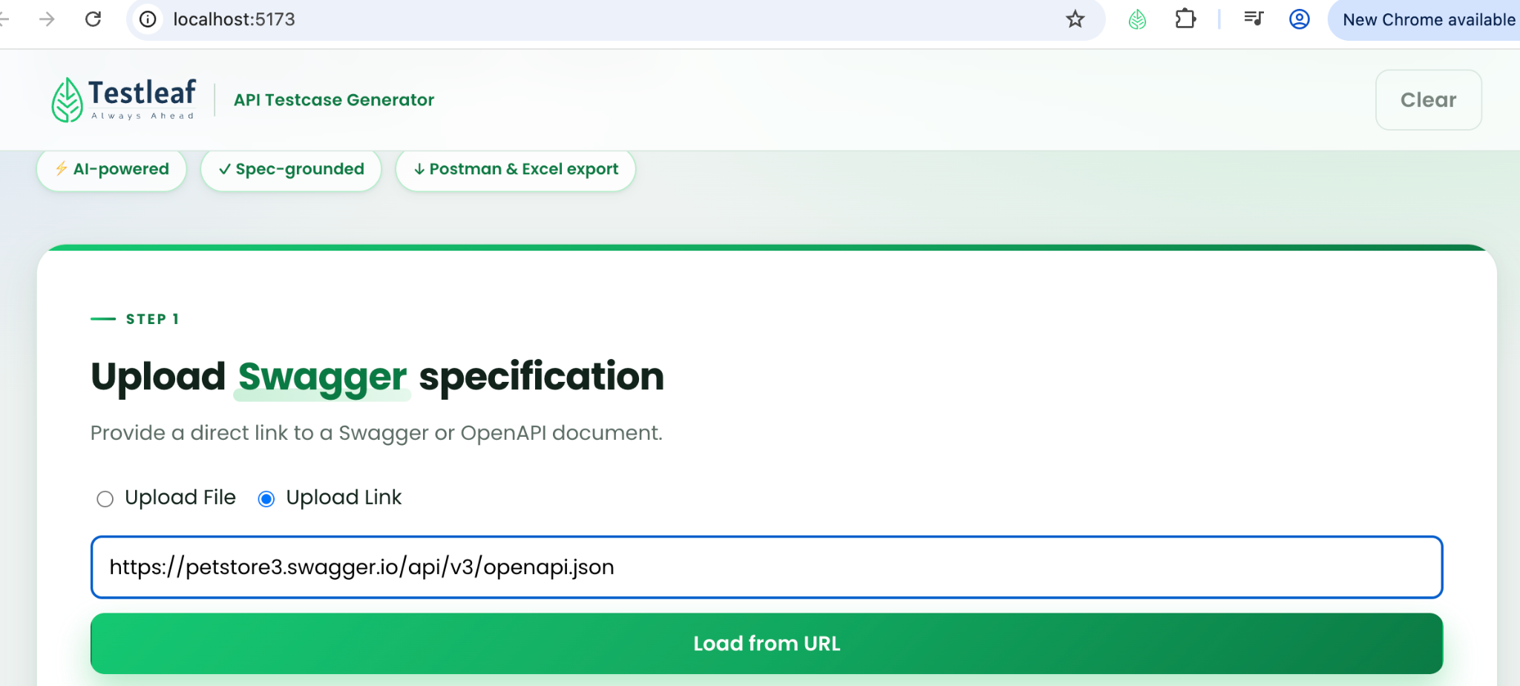
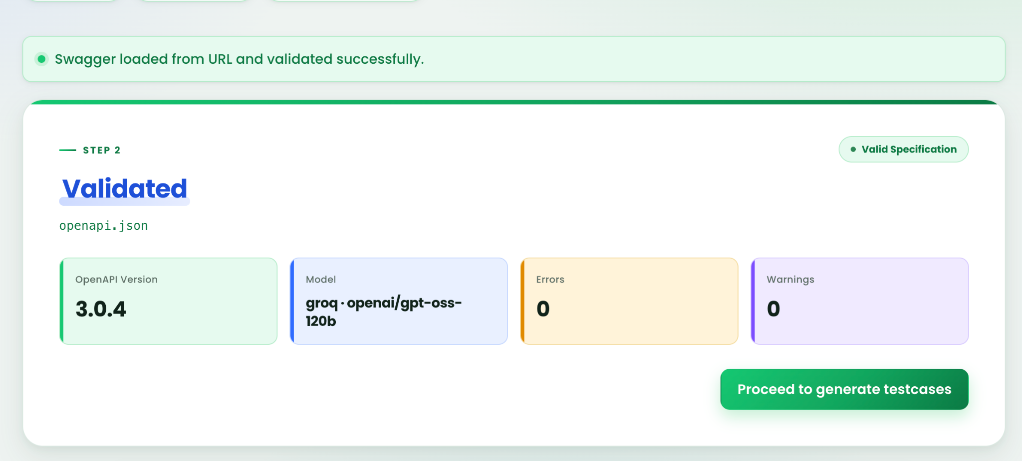
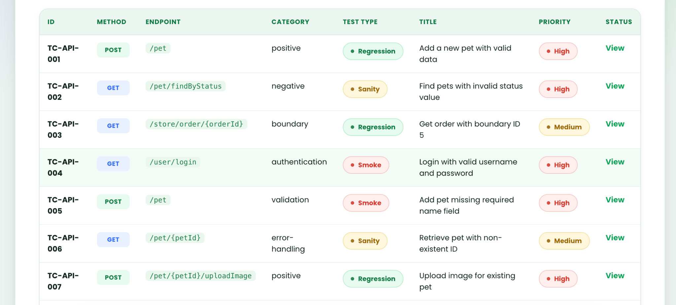

Home Assignment:

Enhance the existing application by implementing a feature that automatically categorizes the generated test cases into standard testing types such as Smoke, Sanity, Regression, Functional.

Once the test cases are generated, the application should classify each test case into the most appropriate category and display the categorized results in a structured and user-friendly format
The new functionality should seamlessly integrate with the existing test case generation workflow without impacting current features

Prompt:
Plan: Act as a senior QA automation architect and full-stack developer.
Ask: Analyze the existing application and plan a feature that automatically
categorizes generated test cases into:
- Smoke
- Sanity
- Regression
- Functional

Agent:
1. Inspect the current test-generation workflow, response format,
data models, UI components, and export functionality.
2. Propose classification rules for each category. These categories can
overlap, but this feature must assign one primary category per test
case. Explain how overlapping cases will be handled.
3. Identify whether classification should happen during generation
or as a separate step, and explain the trade-offs.
4. Plan a user-friendly display with:
- A Category column or badge for each test case.
- Filters for All, Smoke, Sanity, Regression, and Functional.
- Test-case counts for each category.
5. Preserve test-case IDs, steps, expected results, and existing features.
6. Include category information in existing exports.
7. Handle older test cases without categories and classification failures
without losing generated test cases.
8. Follow the existing architecture, UI styling, and coding standards.
- Files to create or modify and the purpose of each change.
- Proposed classification rules and examples.
- Implementation steps.
- Validation and regression-testing approach.
- Assumptions or questions requiring clarification.

Do not modify files yet. Wait for my approval.

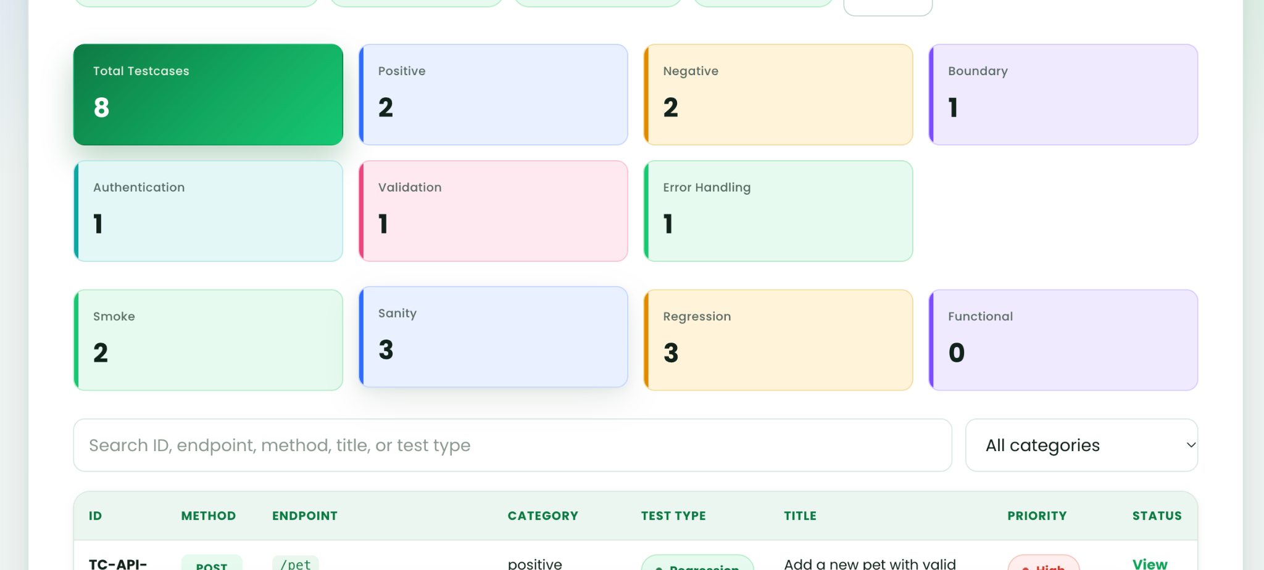
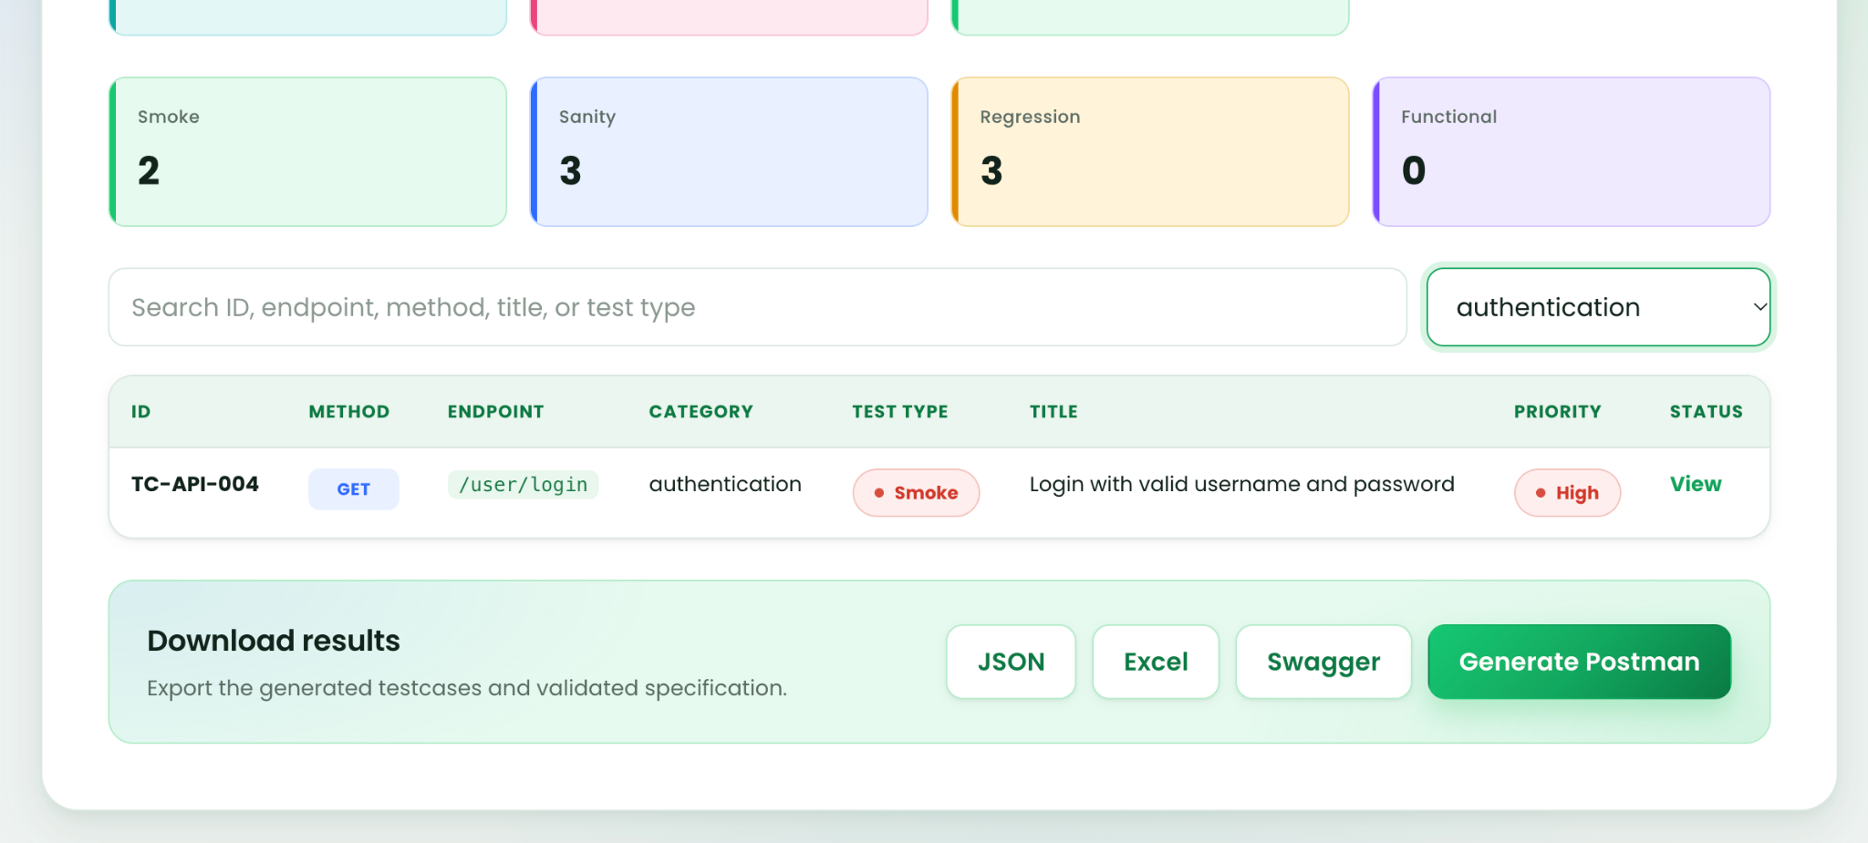

DAY2: MCP_Integration:

Class Work: MCP Model integration and TestLeaf -> Create lead test code creation:

